

Title: Employee Retention and Turnover in Security Agencies: Challenges and Strategies

Supervisor: Aron Truss

Student Number: UP2192433

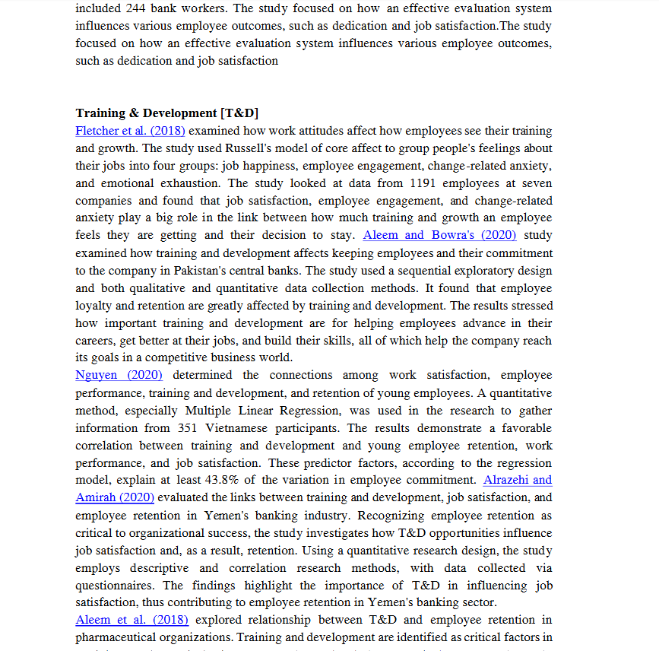

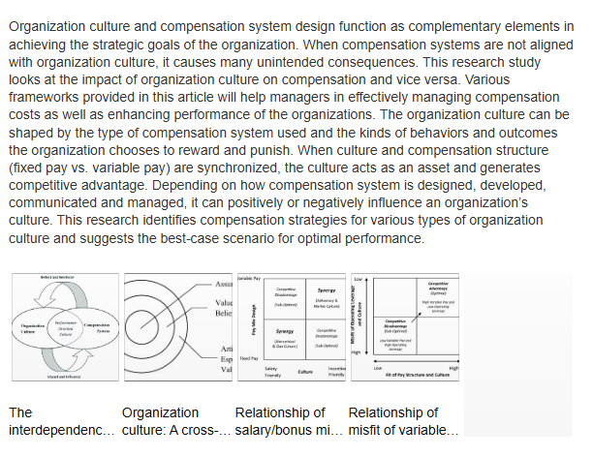

## 

## 

## 

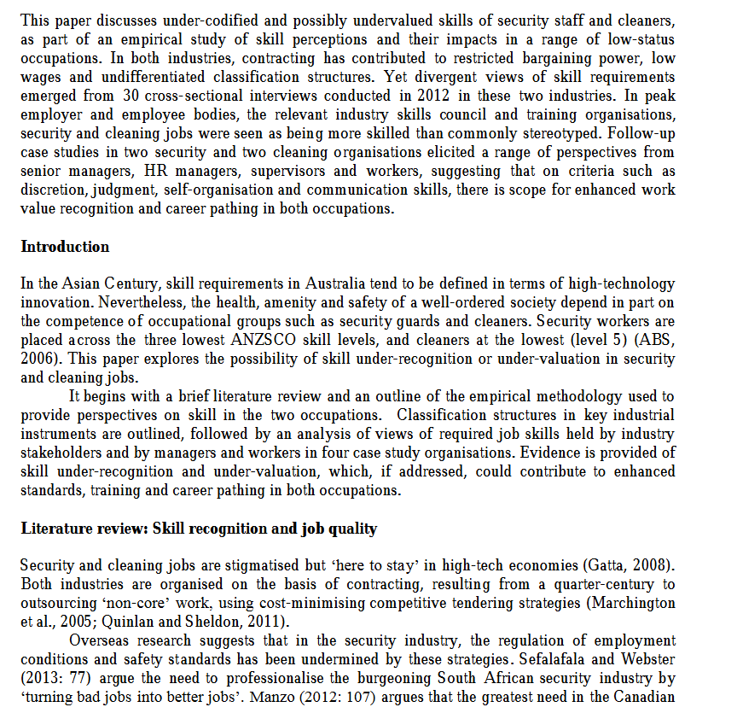

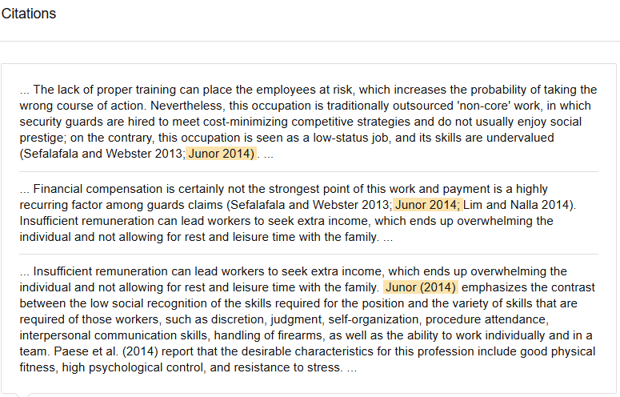

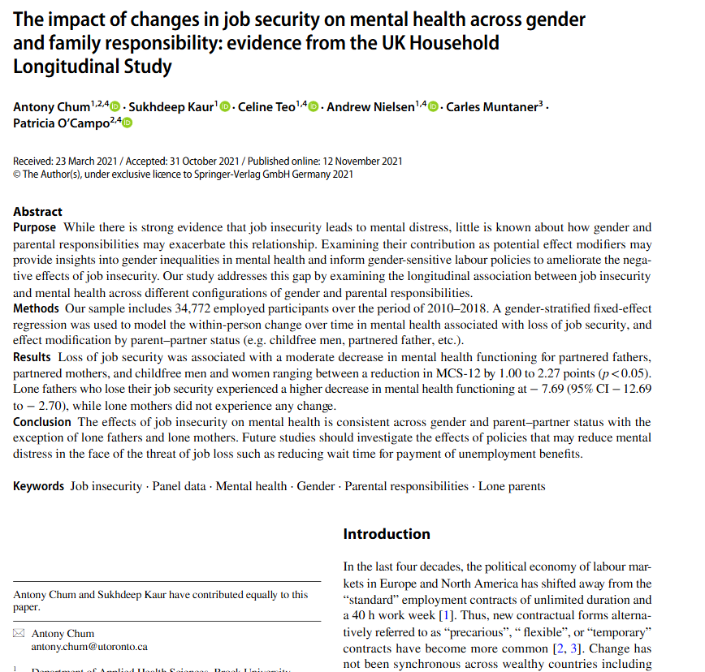

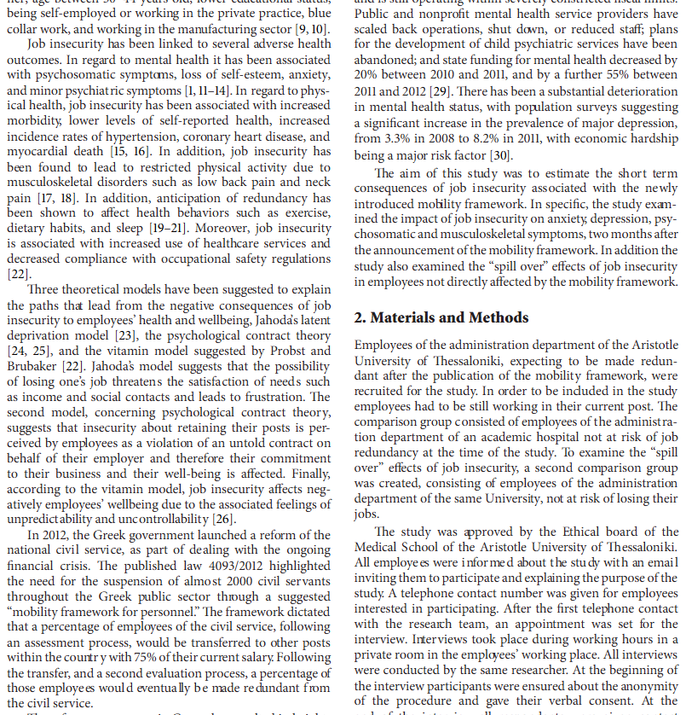

## 

## 

## Initial codes and themes and initial codebook:

|  |  |  |  |
| --- | --- | --- | --- |
| **Initial Code** | **Theme** | **Definition** | **Key Quotes** |
| Inadequacy | Organizational Support Challenges | Inadequate support in various forms (e.g., resources, compensation, mental health services). | "Job satisfaction, employee engagement, and change-related anxiety play a big role in the link between how much training and growth an employee feels they are getting and their decision to stay." "According to the Nguyen, the interplay between work satisfaction, employee performance, training and development, and retention among young employees, further highlighting the critical role of professional growth in fostering employee loyalty."  "Compensation packages are frequently misaligned with the demands of security work." |
| Poor Work-Life Balance | Work-Life Integration Issues | The imbalance between professional demands and personal life responsibilities. | "Personnel often work unpredictable shifts that interfere with their ability to maintain personal commitments."  "The lack of predictable schedules creates constant stress for employees."  "High job demands and inflexible hours lead to burnout among security workers." |
| Limited Career Progression | Career Development Limitations | Lack of growth opportunities, promotion, or skill enhancement within the industry. | "Security roles are frequently perceived as ‘dead-end’ jobs, with limited avenues for professional growth."  "Organizations rarely provide structured pathways for skill enhancement."  "The lack of promotional opportunities leaves employees feeling stagnant and undervalued." |
| Lack of Mental Health Support | Employee Wellbeing | Absence of sufficient mental health support and resources for employees in high-stress environments. | "Mental health is a growing concern amongst UK employers."  "Exposure to traumatic events without support leaves employees vulnerable to psychological distress." |
| Organizational Culture Challenges | Work Environment and Engagement | Poor organizational culture, including a lack of employee recognition and inclusivity, leading to disengagement. | "Workplaces that neglect inclusivity, employee recognition, or meaningful engagement foster disengagement."  "Employees often feel that their contributions are overlooked, leading to dissatisfaction."  "A toxic work environment can significantly impact employee morale and retention." |